# BB8 demo environment setup

All required software is stored in the Box folder: <https://ibm.ent.box.com/folder/23139147145>

- Emotiv ControlPanel (osx app)

- Emoviv Emokey (osx app)

- Bb8node (node.js app)

- Bb8html (html page)

All software above must be installed and configured in a local machine (Mac).

The 2 Emotiv apps just unzipped and copied into Applications folder in the mac.

Bb8node and Bb8html in any path on the disk. Configuration must be done for these 2.

Node.js must be installed in the demo machine

This is the component diagram interaction used for this scenario:

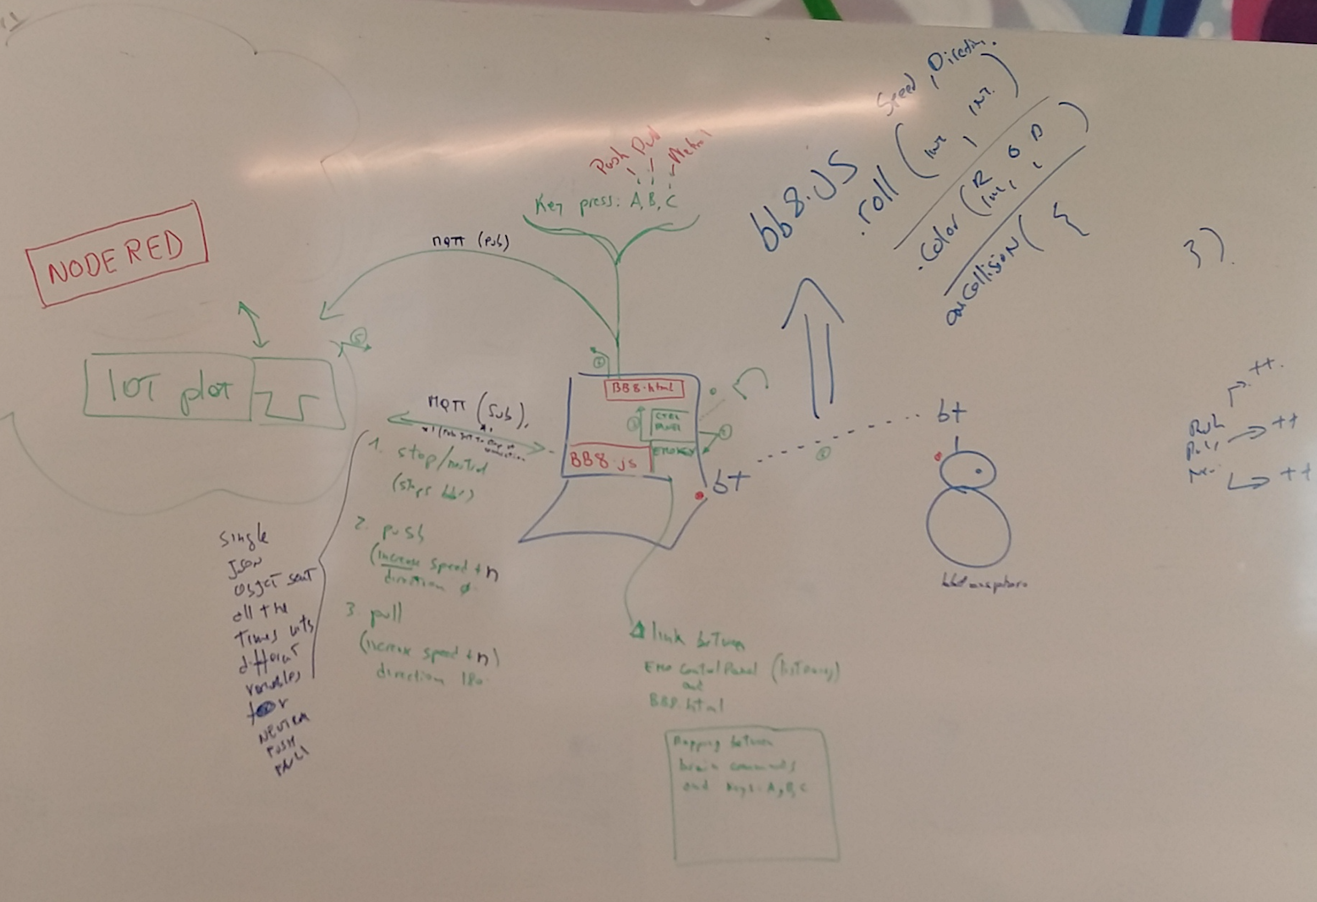

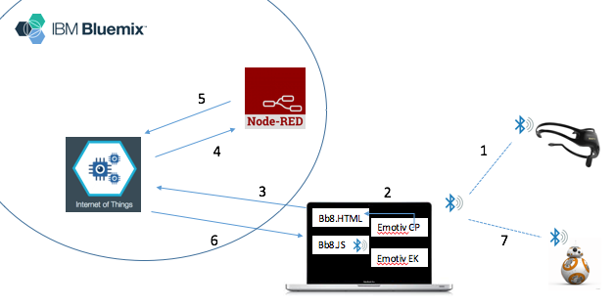

Below the flow sequence:

1. X
2. X
3. X
4. X
5. X
6. X
7. x

## Emotiv headset

It must be charged and disconnected from power in order to be used. If connected to power it won’t communicate with the laptop (Bluetooth).

Power indicator is not the one next to the power button but a small one on the larger plastic part (with headset name)

## BB8

It works on Bluetooth, it connects and talk to the laptop (Mac).

BB8 must be discovered in order to get it’s UUID, to do this a node.js program (see BB8 node.js section for details) must be run.

$ cd /Users/giovanni/opt/bb8/bb8node/node_modules/noble/examples

$ node advertisement-discovery.js

peripheral discovered (2716d1f08a5842b7ac37502a273772df with address <unknown, unknown>, connectable true, RSSI -55:

hello my local name is:

BB-A7A9

can I interest you in any of the following advertised services:

[]

here is my manufacturer data:

"3330"

my TX power level is:

-10

It returns a list with all the discovered Bluetooth devices, **BB-xxxx** is the BB8 and the long exadecimal string is the UUID

## BB8 html

This is a fundamental piece of the demo, everything works **ONLY** if the page is loaded in a browser and the input field in on focus.

It accept Keyboard keystrokes and send messages to IBMIOT (or any other action if coded).

Only 2 keys accepted are:

a = PUSH

b = PULL

c = NEU (Neutral)

Only a parameter must be customized in the code: uID (see below)

var uID = "d:quickstart:TestDevice:gv1234";

‘**gv1234’** is an arbitrary name (pick whatever you like) that is assigned to the device (bb8 drone in this case).

The same string (**gv1234**) is used in the NodeRed flow (refer to NodeRed section of this document) in the ‘ibmiot’ input node.

The javascript function uses IBMIOT quickstart to make a connection. Quickstart uses an preconfigured IBMIOT instance, so not configuration on IBMIOT is needed at this stage.

Copy and expand ‘bb8html.zip/ in the filesystem (e.g. /Users/giovanni/opt/bb8/bb8html), open with an editor bb8.html and replace ‘gv1234’ with a unique name. Note down this name as it will be used later on.

Open a browser and run bb8.html

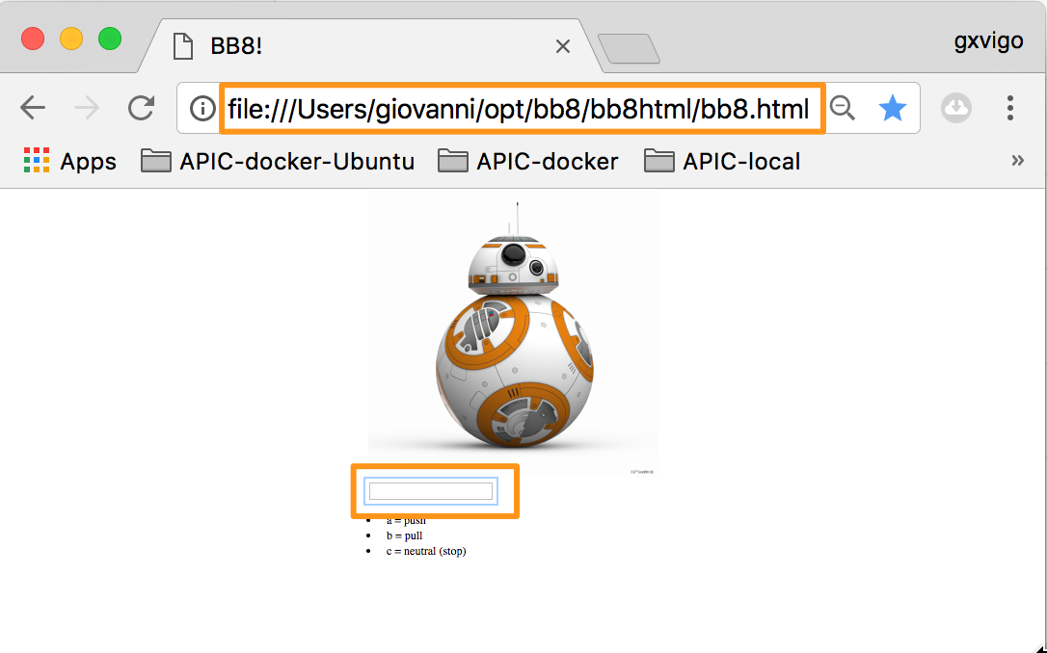

## BB8 node.js

Copy and expand ‘bb8node.zip/ in the filesystem (e.g. /Users/giovanni/opt/bb8/bb8node).

The folder should be ready to be used. It there’s any issue running the app, it’s possible to recreate that issuing the following command:

$ npm install

(this reads package.json file and copies into node_modules the 3 required modules: noble, sphero, ibmiotf)

Then rename the file bb8_BACKUP-RUN-FROM-IBMIOTF-MODULE.js to bb8.js and copy into the folder: /Users/giovanni/opt/bb8/bb8node/node_modules/ibmiotf

$ mv bb8_BACKUP-RUN-FROM-IBMIOTF-MODULE.js ./node_modules/ibmiotf/bb8.js

Open ./node_modules/ibmiotf/bb8.js and customize the following sections:

var orb = sphero("1e26f18958bc4771b183d013689555dc");

replace the string above with the bb8 UUID you got from setting up BB8 (advertisement-discovery.js)

var appClientConfig = {

  org: '4v2p8m',

  id: 'giovannibb8',

  "auth-key": 'a-4v2p8m-k88ktxgn2w',   // API Key from IBMIOT App

  "auth-token": '11!69DQZr1EuyGIuqR'   // Auth token from IBMIOT App

};

Org and id comes from the **Device** created in the section ‘IBM IOT’ and the auth-key and auth-token from the **App**

appClient.publishDeviceCommand("bb8","giovannibb8", "move", "json", '{"5":"neu"}');

appClient.publishDeviceCommand("bb8","giovannibb8", "move", "json", '{"5":"neu"}');

bb8 and giovannibb8 above comes from the **Device** created in the section ‘IBM IOT’

These customizations can be completed only after an instance of IBMIOT has been created in Bluemix (refer to section ‘IBM IOT’).

Once the customizations are done, run bb8.js as described below:

- $ cd /Users/giovanni/opt/bb8/bb8pipytojs/node_modules/ibmiotf/

- $ node bb8.js

At this stage bb8 device (the physical object) should light up in green color. Once the connection is lost it turns red and eventually no light.

## IBM IOT

IBM Internet of Things is used to …

In Bluemix create an instance of IOT (e.g. Bluemix US South, darkside space)

<https://console.ng.bluemix.net/dashboard/apps/>

As example:

Region: US South

Organization: [Giovanni@nz.ibm.com](mailto:Giovanni@nz.ibm.com)

Space: darkside

<https://4v2p8m.internetofthings.ibmcloud.com/dashboard/#/boards/>

(Launch from Bluemix console if direct link doesn’t work)

In IBMIOT console:

Create an **App** (type device):

API Key: **a-4v2p8m-k88ktxgn2w**  
Authentication Token: **11!69DQZr1EuyGIuqR**

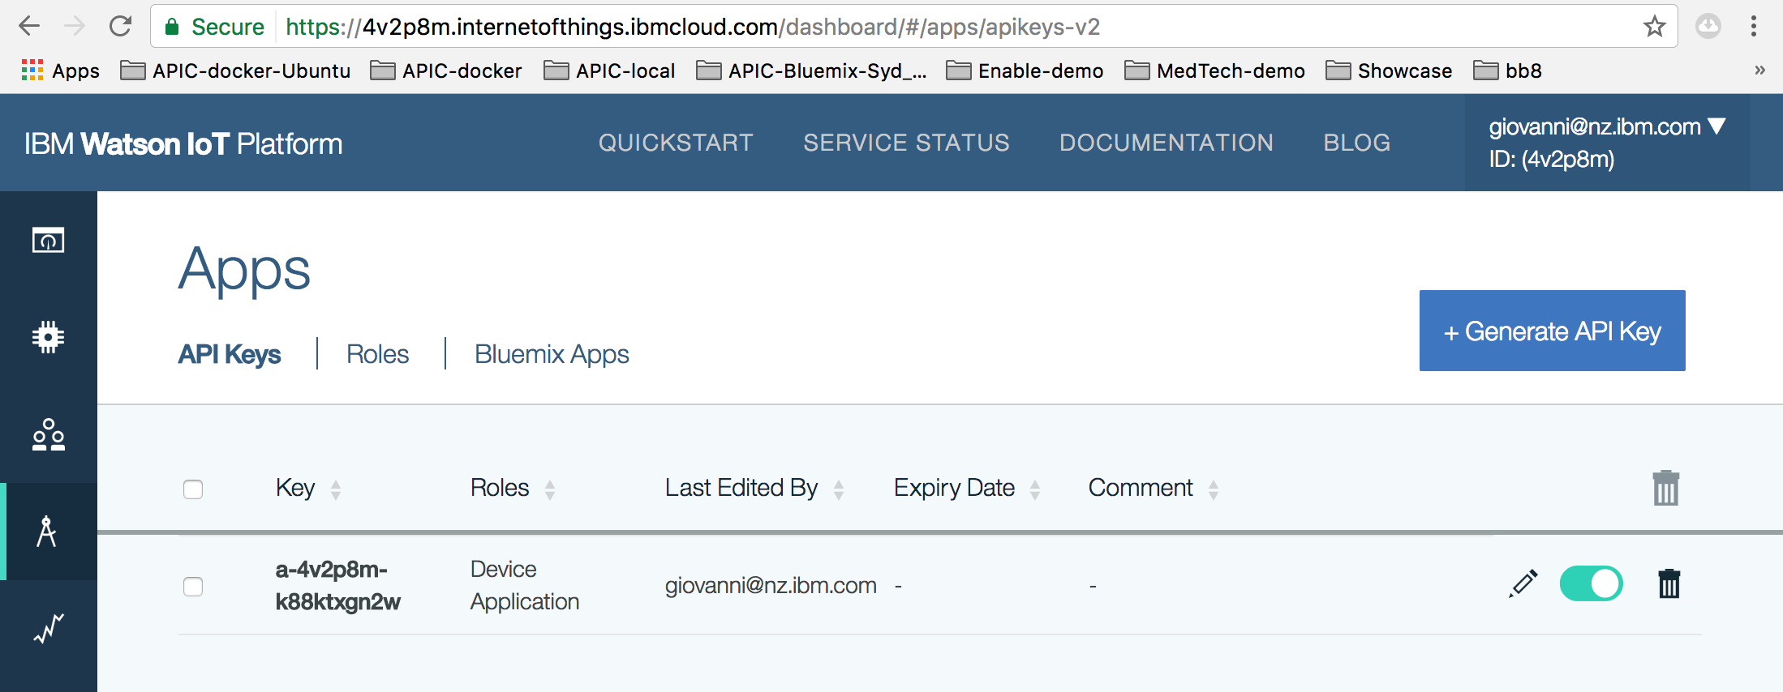

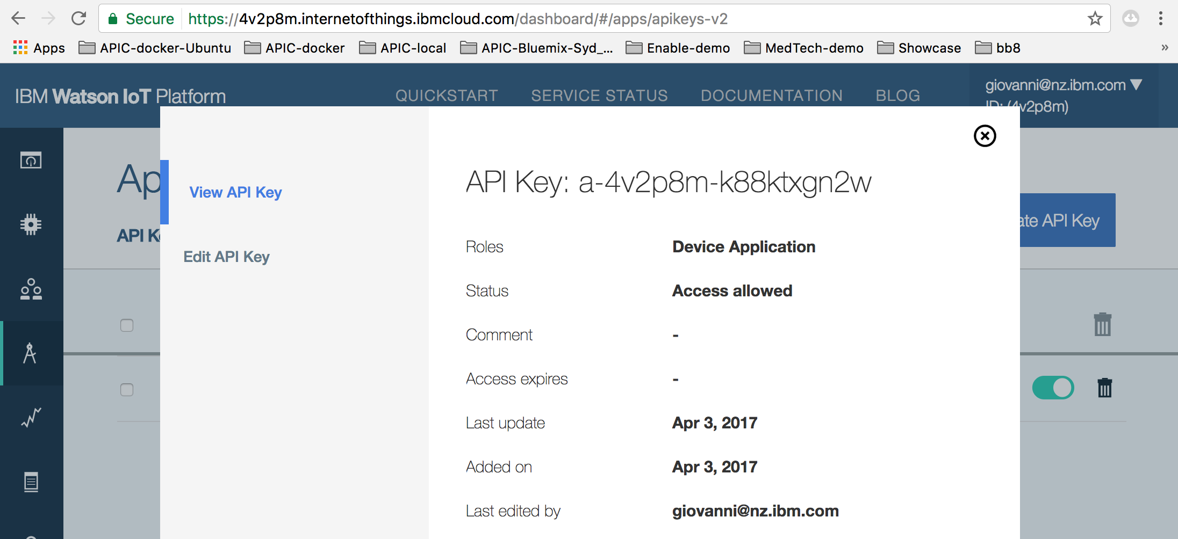

Create a **Device**, just all default (blank) but the device id (makeup one, e.g. giovannibb8), see below for an example of parameters’ summary

Organization: ID **4v2p8m**

Device Type: **bb8**

Device ID: **giovannibb8**

Authentication Method: token

Authentication Token: **aoH*rY)ybSyGhl9yG&**

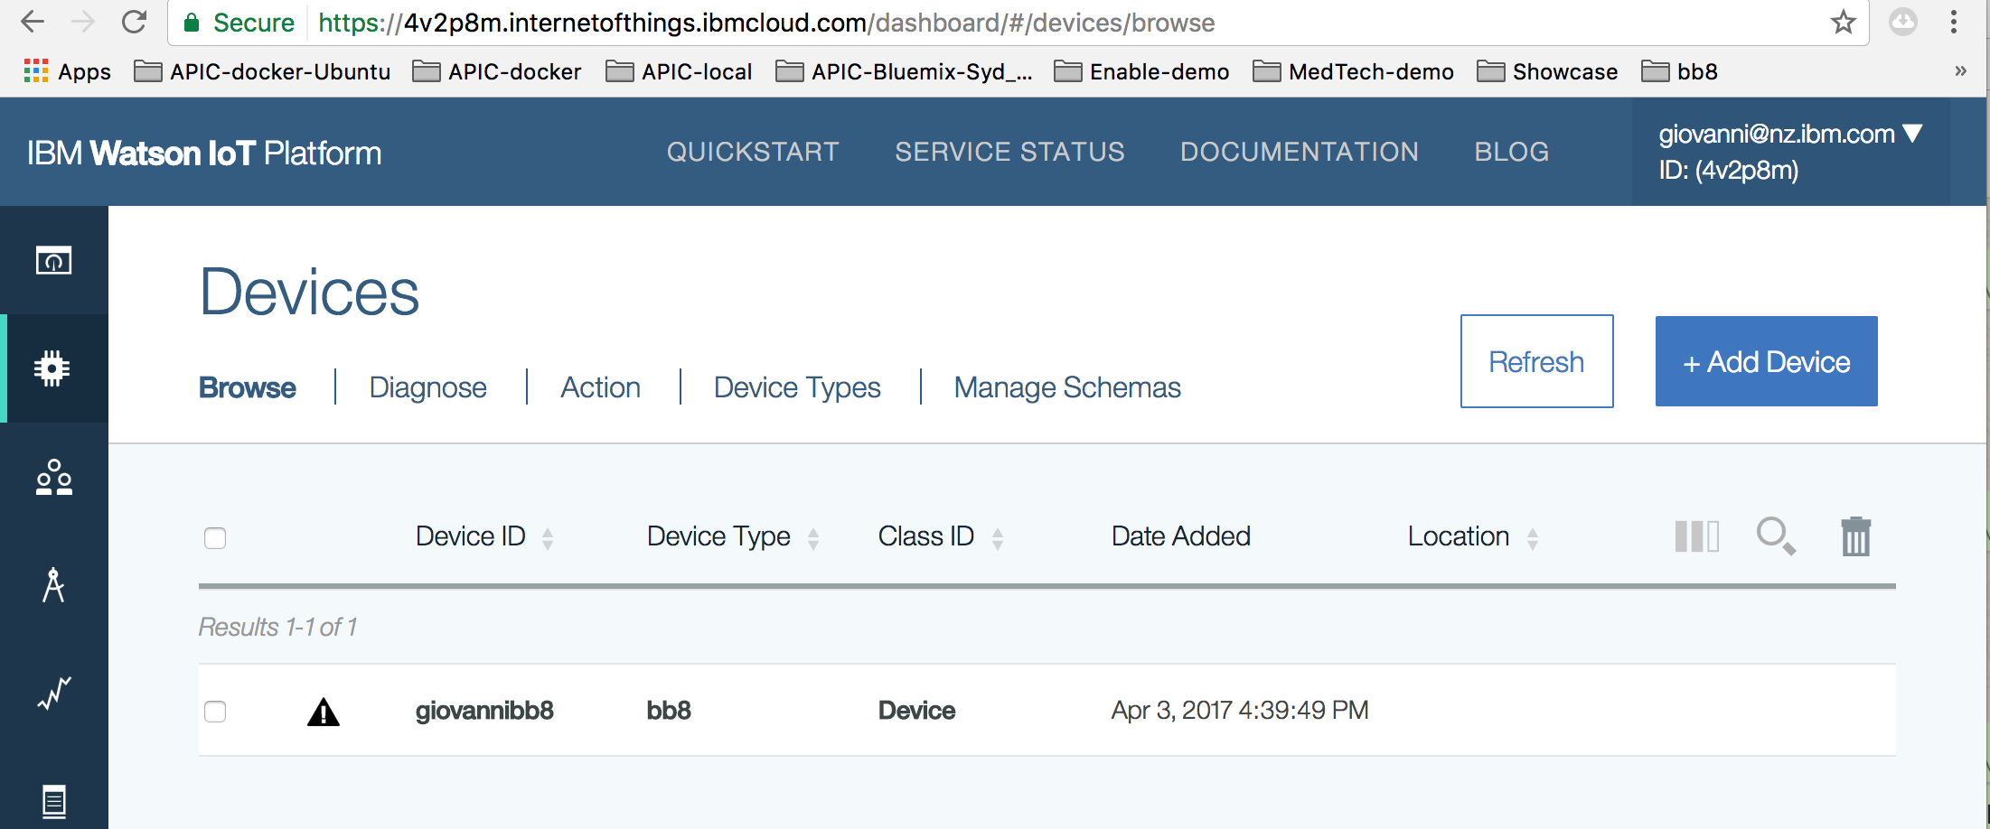

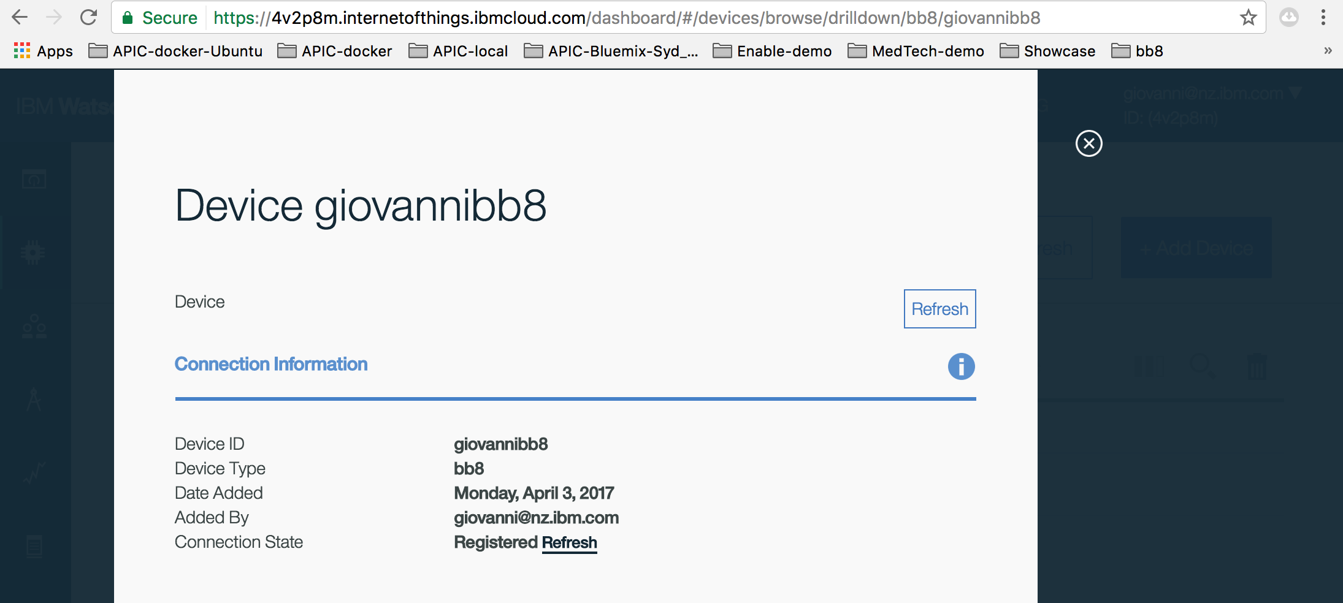

## NodeRed

The NodeRed flow below is used to get messages (JSON object) from IBMIOT, transform the messages into ‘actions’ and send back to IBMIOT.

Messages from IOT are always the same:

push: x, pull: y, neu: z

The ‘transformation’ is actually adjusting the value of the actions (push, pull, neu) based on the received action.

Below the flow logic and logic for each node:

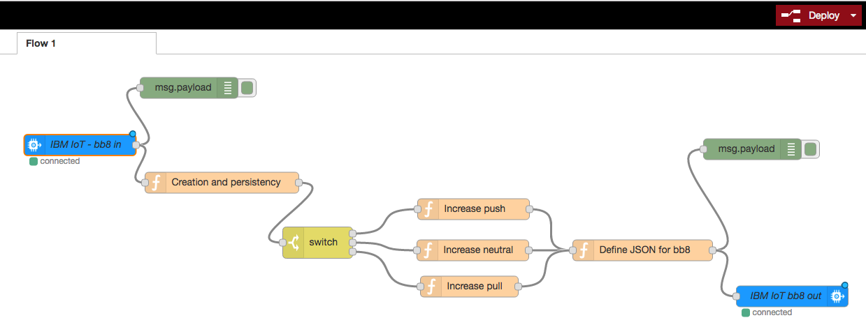

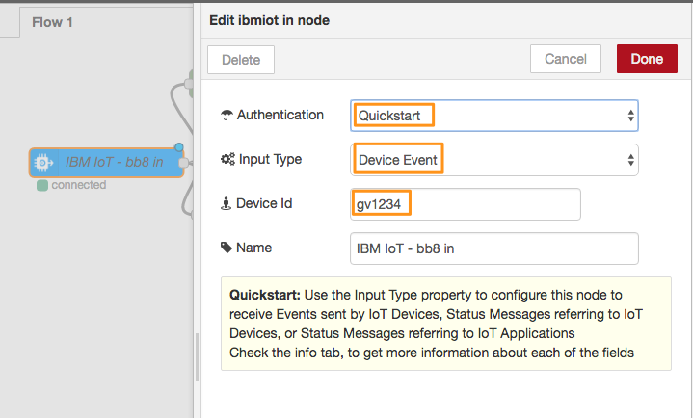

The IBMIOT input node uses IBMIOTF quickstart, no configuration is required to connect to the IOT instance, just Device Id (same defined in bb8.html)

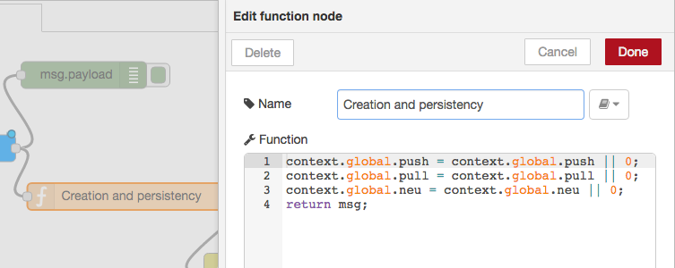

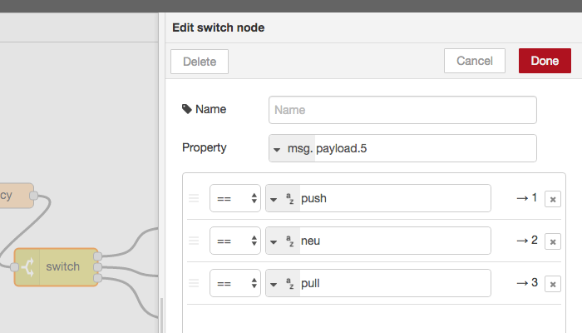

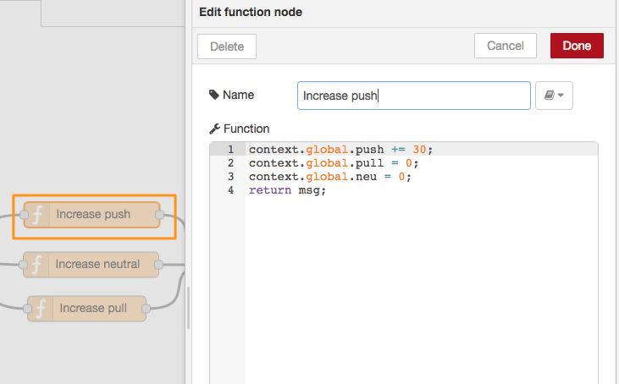

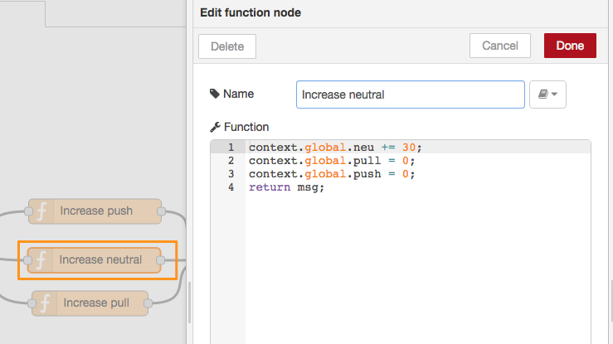

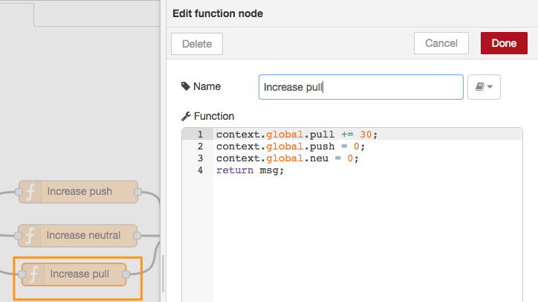

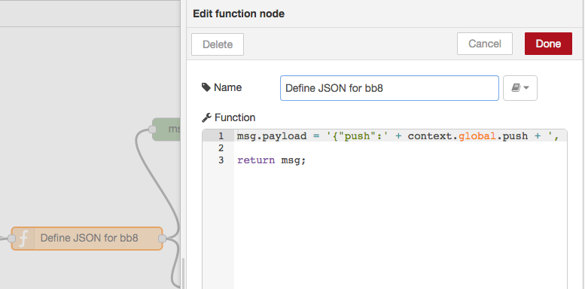

msg.payload = '{"push":' + context.global.push + ', "pull":' + context.global.pull + ', "neu":' + context.global.neu + '}';

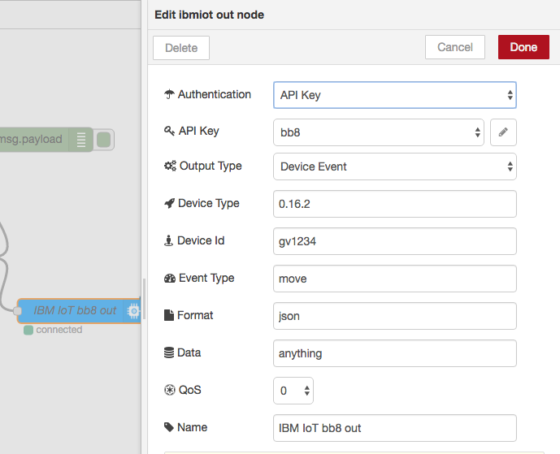

IBMIOT output node uses the IBMIOTF instance created during this procedure. It requires some configuration. Device Id (same as input) and API Key (see below) from App defined in IBMIOTF App

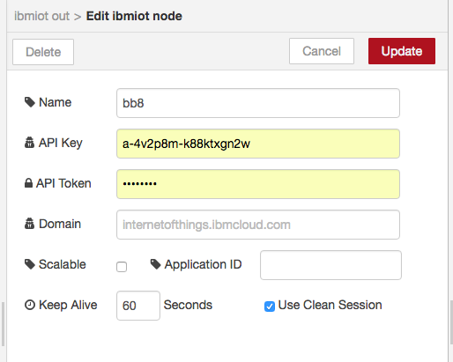

Be sure that the flow is **deployed**. Activating the debug node and viewing the debug panel is a great tool for troubleshooting.

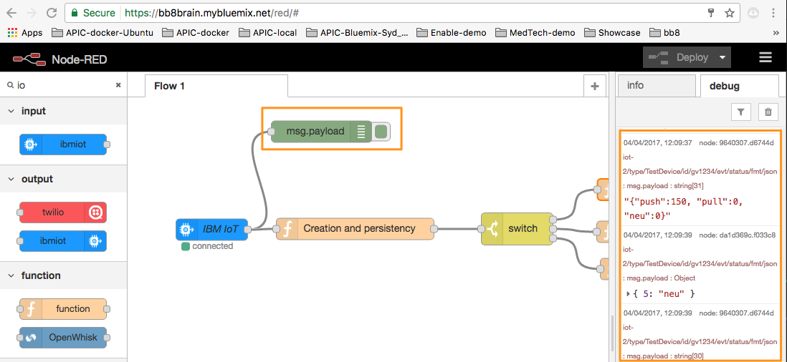

Flow source code:

[{"id":"710342a.76a2ebc","type":"tab","label":"BB8 motion control"},{"id":"cf0c3775.1676b8","type":"ibmiot in","z":"710342a.76a2ebc","authentication":"quickstart","apiKey":"","inputType":"evt","deviceId":"gv1234","applicationId":"","deviceType":"+","eventType":"+","commandType":"","format":"json","name":"IBM IoT - bb8 in","service":"quickstart","allDevices":"","allApplications":"","allDeviceTypes":true,"allEvents":true,"allCommands":"","allFormats":"","qos":0,"x":114.5,"y":130,"wires":[["da1d369c.f033c8","c5bb4e6c.638f4"]]},{"id":"da1d369c.f033c8","type":"debug","z":"710342a.76a2ebc","name":"","active":true,"console":"false","complete":"false","x":270.5,"y":48,"wires":[]},{"id":"b4a759ab.1b6038","type":"switch","z":"710342a.76a2ebc","name":"","property":"payload.5","propertyType":"msg","rules":[{"t":"eq","v":"push","vt":"str"},{"t":"eq","v":"neu","vt":"str"},{"t":"eq","v":"pull","vt":"str"}],"checkall":"true","outputs":3,"x":454.5,"y":270,"wires":[["d7ff25b.b33d9d8"],["b1ee541b.e02bd8"],["e856104f.0f3a8"]]},{"id":"c5bb4e6c.638f4","type":"function","z":"710342a.76a2ebc","name":"Creation and persistency","func":"context.global.push = context.global.push || 0;\ncontext.global.pull = context.global.pull || 0;\ncontext.global.neu = context.global.neu || 0;\nreturn msg;","outputs":1,"noerr":0,"x":317.5,"y":184,"wires":[["b4a759ab.1b6038"]]},{"id":"268b0ffe.e640f","type":"function","z":"710342a.76a2ebc","name":"Define JSON for bb8","func":"msg.payload = '{\"push\":' + context.global.push + ', \"pull\":' + context.global.pull + ', \"neu\":' + context.global.neu + '}';\n\nreturn msg;","outputs":1,"noerr":0,"x":919.5,"y":281,"wires":[["9640307.d6744d","1048a521.6a8a4b"]]},{"id":"d7ff25b.b33d9d8","type":"function","z":"710342a.76a2ebc","name":"Increase push","func":"context.global.push += 30;\ncontext.global.pull = 0;\ncontext.global.neu = 0;\nreturn msg;","outputs":1,"noerr":0,"x":677.5,"y":222,"wires":[["268b0ffe.e640f"]]},{"id":"e856104f.0f3a8","type":"function","z":"710342a.76a2ebc","name":"Increase pull","func":"context.global.pull += 30;\ncontext.global.push = 0;\ncontext.global.neu = 0;\nreturn msg;","outputs":1,"noerr":0,"x":671.5,"y":333,"wires":[["268b0ffe.e640f"]]},{"id":"b1ee541b.e02bd8","type":"function","z":"710342a.76a2ebc","name":"Increase neutral","func":"context.global.neu += 30;\ncontext.global.pull = 0;\ncontext.global.push = 0;\nreturn msg;","outputs":1,"noerr":0,"x":676.5,"y":281,"wires":[["268b0ffe.e640f"]]},{"id":"9640307.d6744d","type":"debug","z":"710342a.76a2ebc","name":"","active":false,"console":"false","complete":"false","x":1076.5,"y":136,"wires":[]},{"id":"1048a521.6a8a4b","type":"ibmiot out","z":"710342a.76a2ebc","authentication":"apiKey","apiKey":"c5f0cd6f.9a91e","outputType":"evt","deviceId":"giovannibb8","deviceType":"0.16.2","eventCommandType":"move","format":"json","data":"anything","qos":0,"name":"IBM IoT bb8 out","service":"registered","x":1133.5,"y":347,"wires":[]},{"id":"c5f0cd6f.9a91e","type":"ibmiot","z":"","name":"bb8","keepalive":"60","domain":"","cleansession":true,"appId":"","shared":false}]

## Emotiv ControlPanel

This is the components that translate brain signals into di digital streams and eventually into keyboard keystrokes (Emotiv EmoKey).

Dowload the EmotivXavierControlPanel.app.zip, unzip that and copy into Application folder in the mac.

Once Emotiv Control panel is started login as guest:

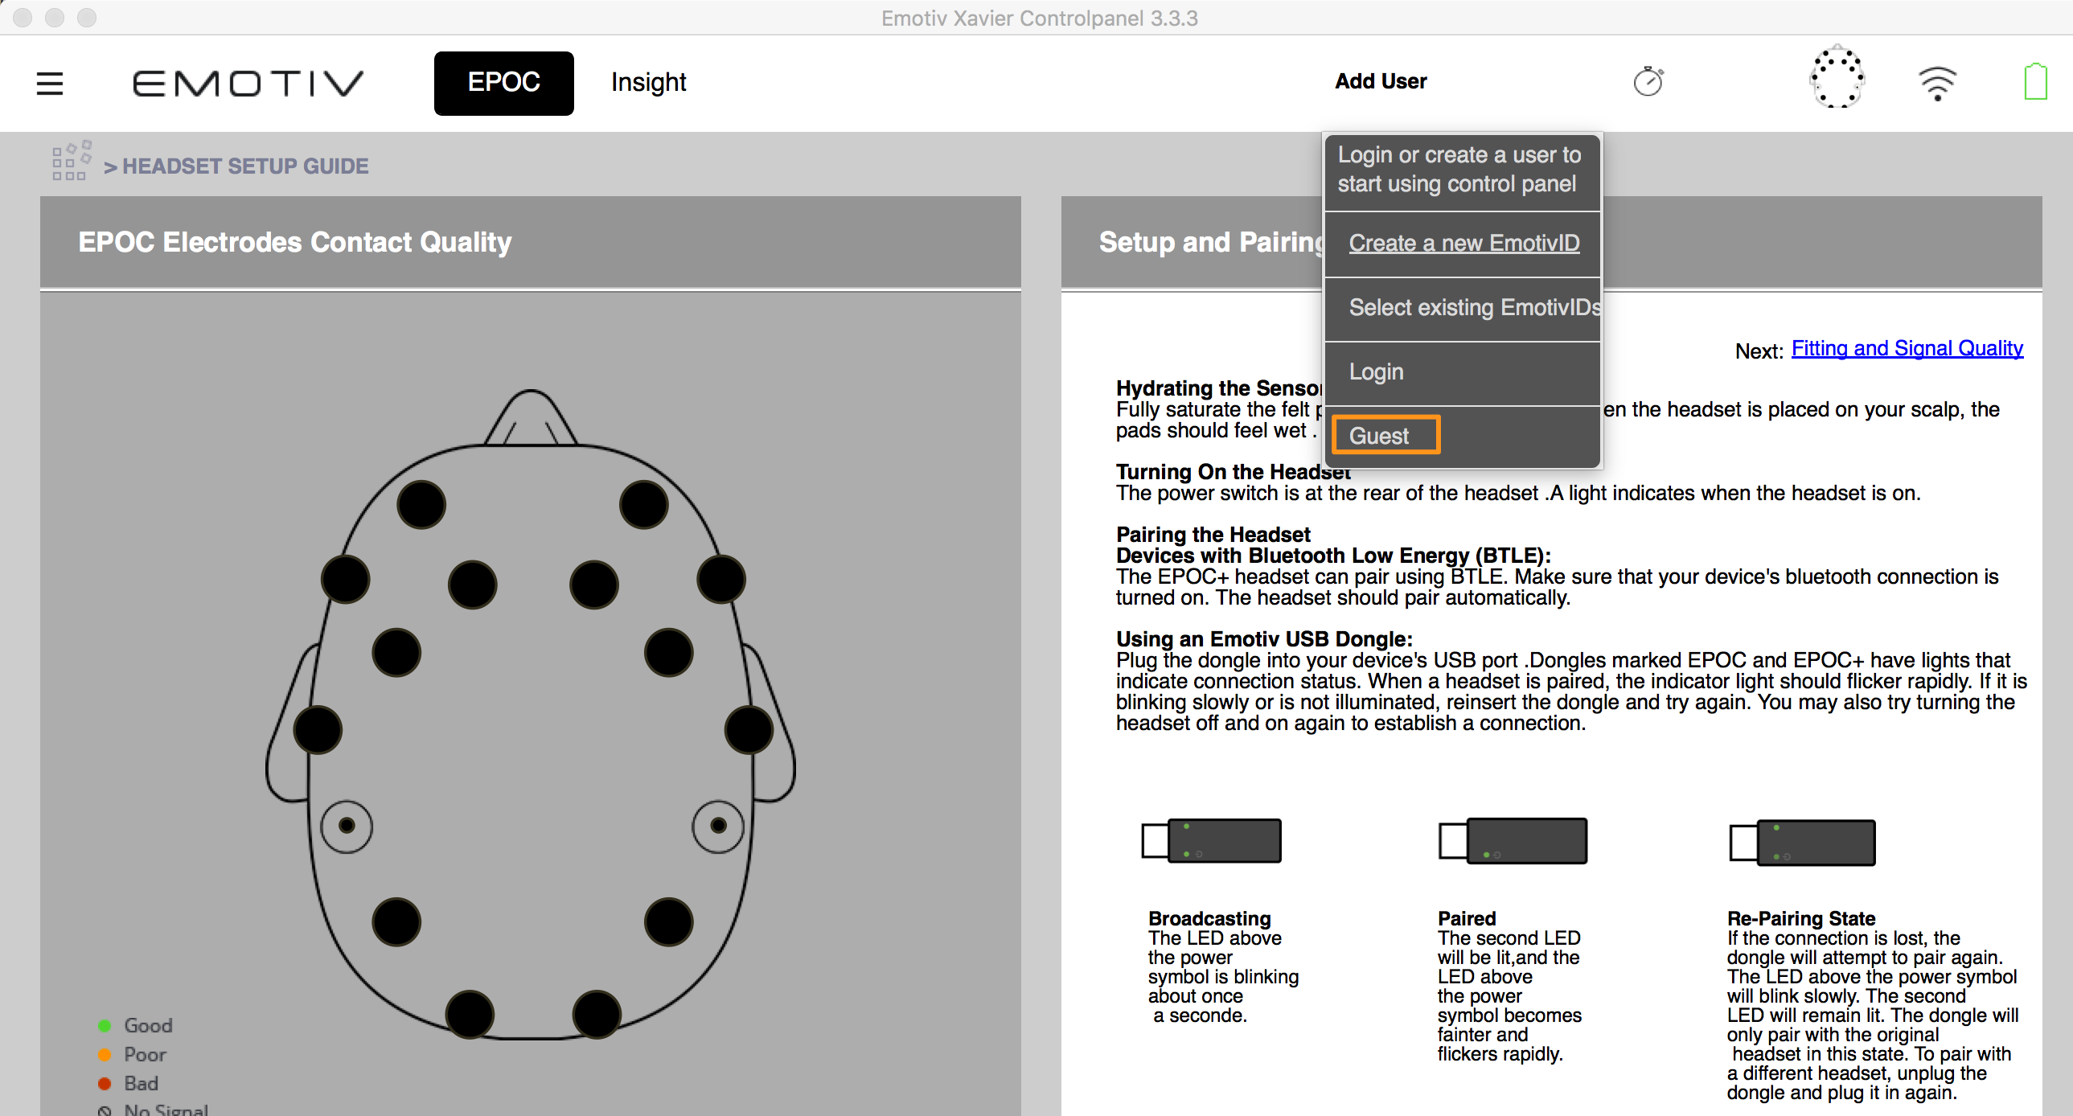

Once the headset is worn at least 6 sensors should be green to work properly.

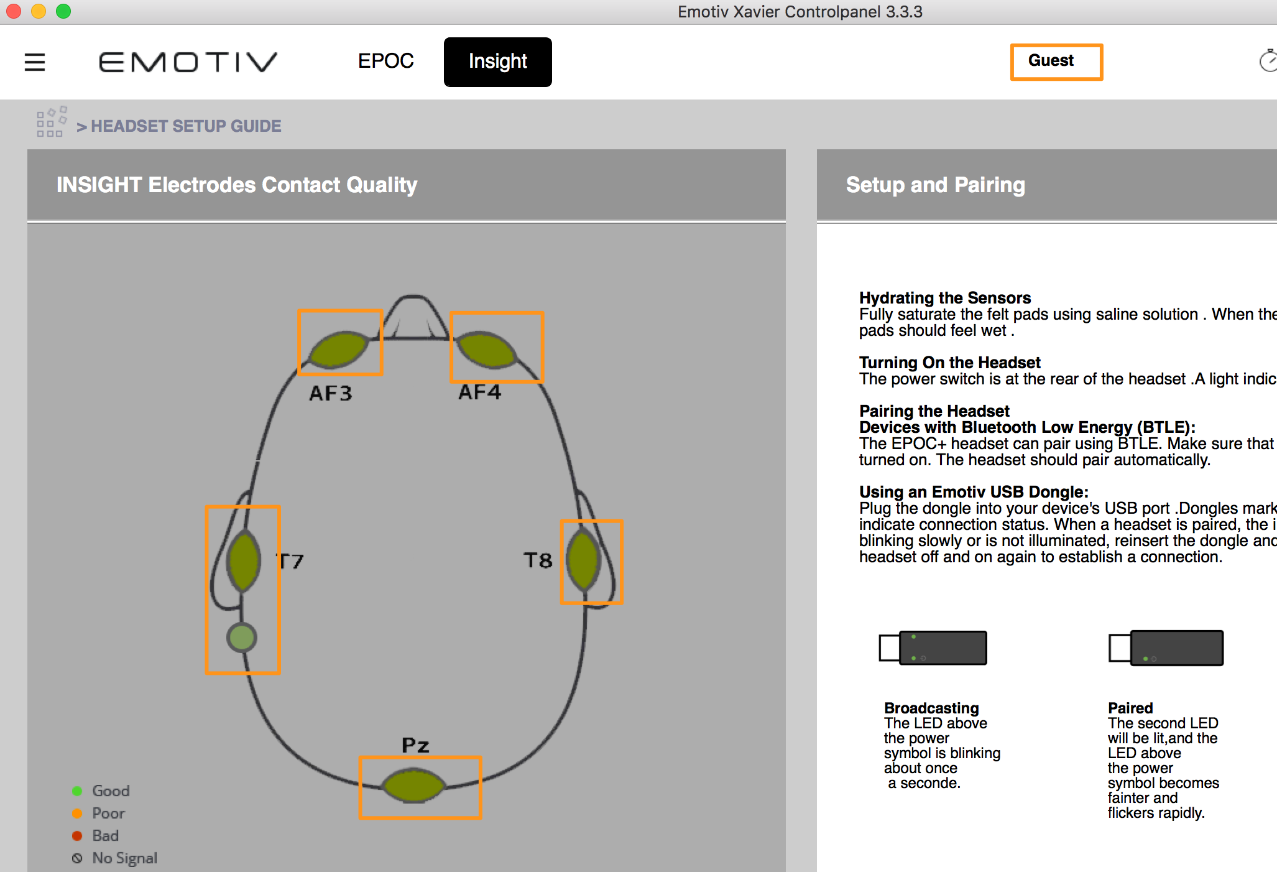

Go to Mental Commands

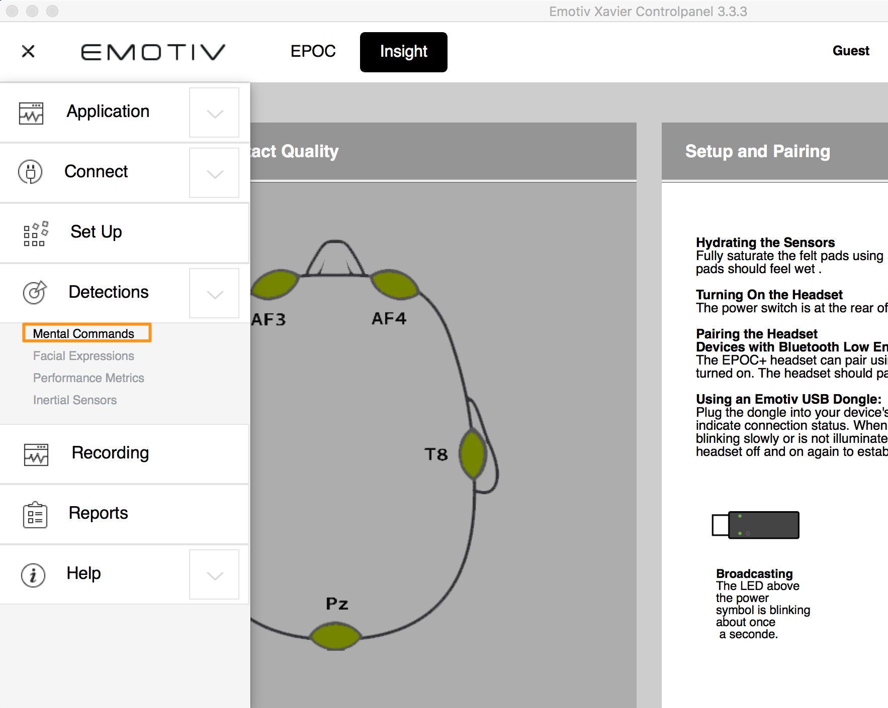

If not already there, add an Action with a Push action

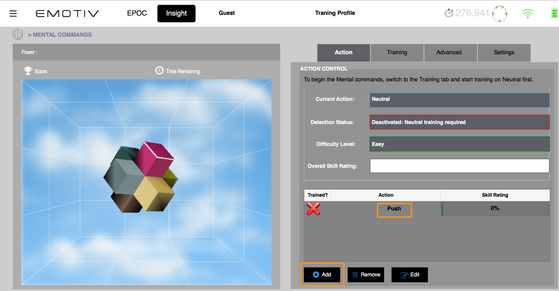

It’s now necessary to train Emotiv to understand mental thoughts and associate to actions.

First train Neutral. This is fundamental to create a baseline and then building thoughts/commands on top of that. To do so, go to Training, select Neutral and Start Training. During the training it’s important not to think to nothing and not to think to anything specific.

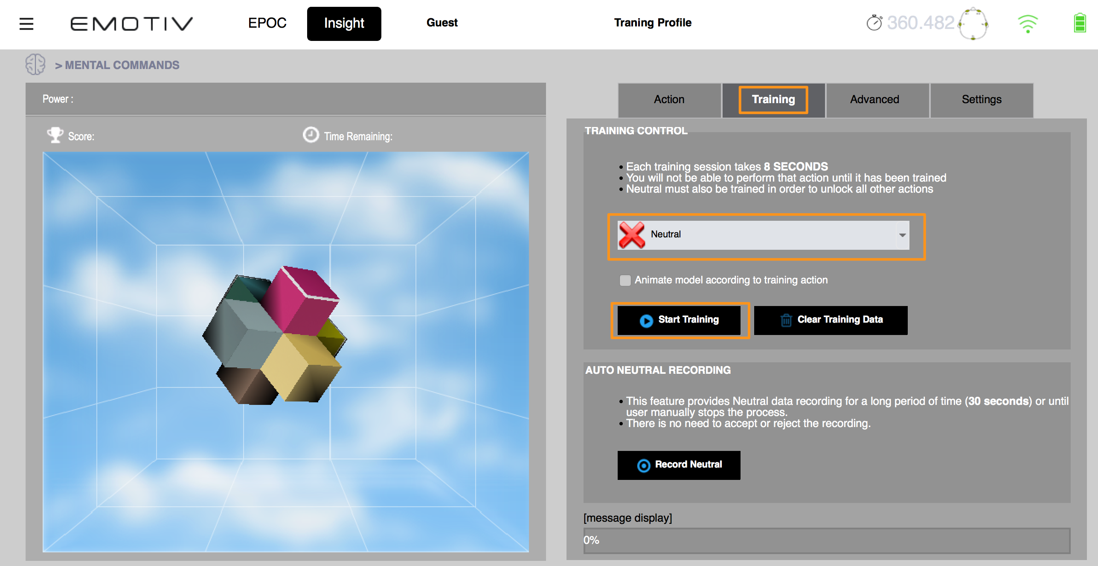

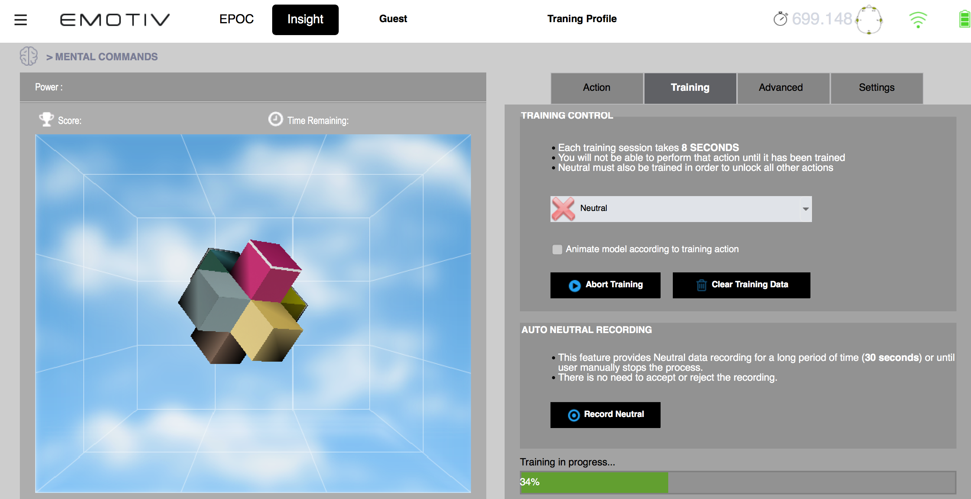

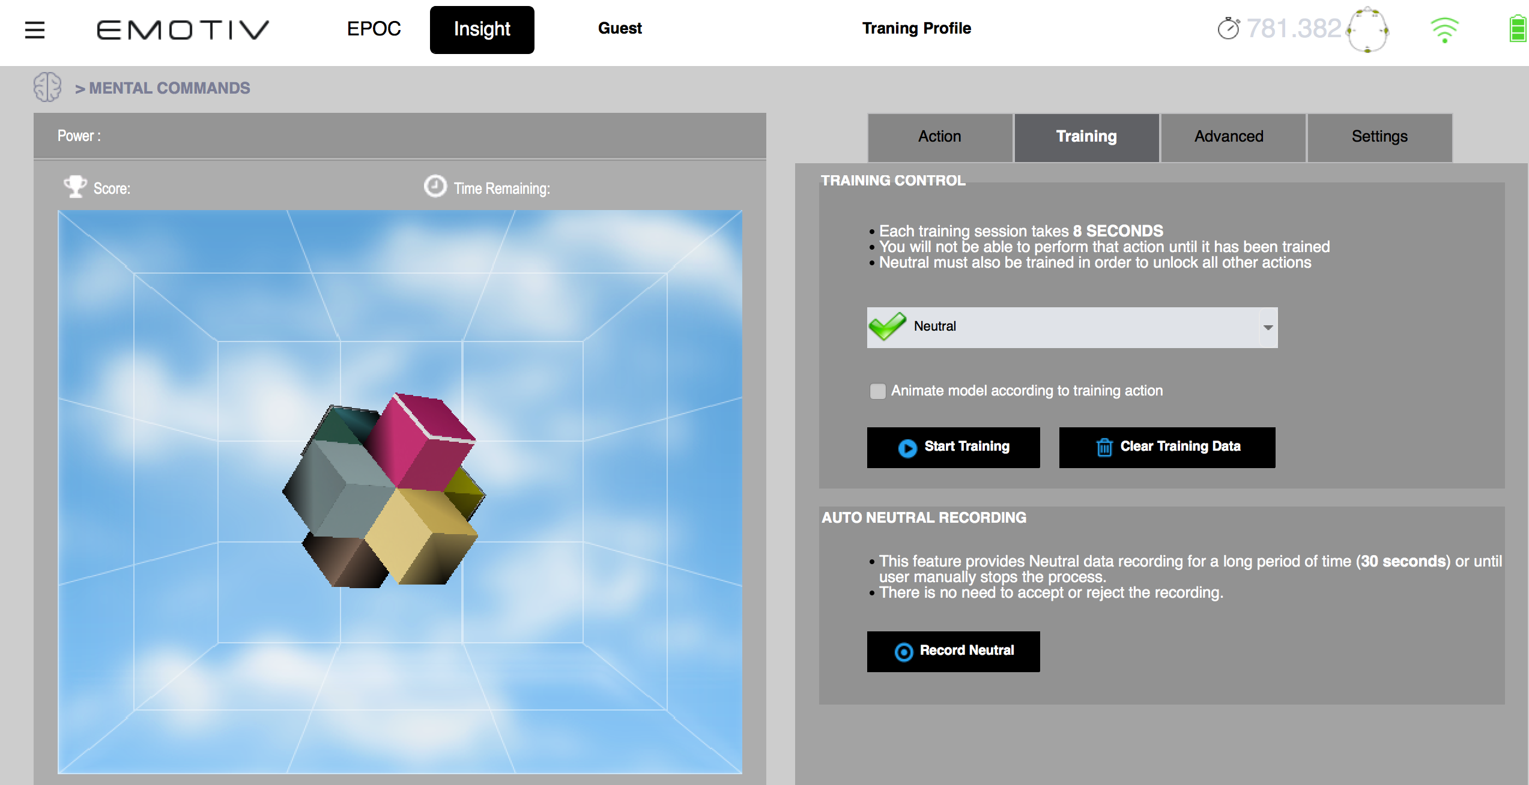

Now select Push and click on Start Training. During the training think about something really specific (something you do every day, or very intense. It can help even a physical action like pushing a finger or similar)

After than on the right side of the Control Panel you should be able to see the Power bar moving if you are thinking the thought you recorded for Push.

## Emotive EmoKey

This is the components that associates digital streams from Control Panel to keyboard keystrokes.

Dowload the EmotivXavierEmoKey.app.zip, unzip that and copy into Application folder in the mac.

Once started it’s necessary to configure at least 2 Keystrokes: ‘**a’** for ‘push’ and ‘**c’** for ‘neutral’ (neu).

For each keystroke a trigger condition must be configured.

For Key ‘a’ (named Push below) create a trigger condition for **Push** Action and “**is greater than**” as Trigger and ‘0.2’ as Value

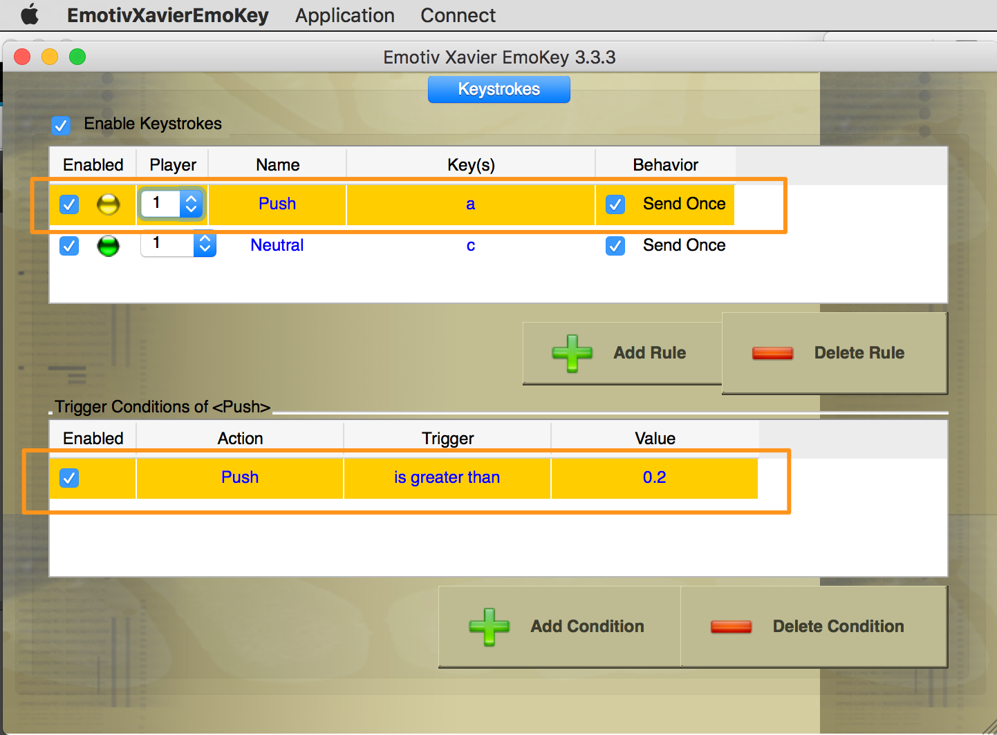

For Key ‘**c’** (named Neutral below) create a trigger condition for **Neutral** Action and “**is greater than**” as Trigger and ‘0.2’ as Value **occours**

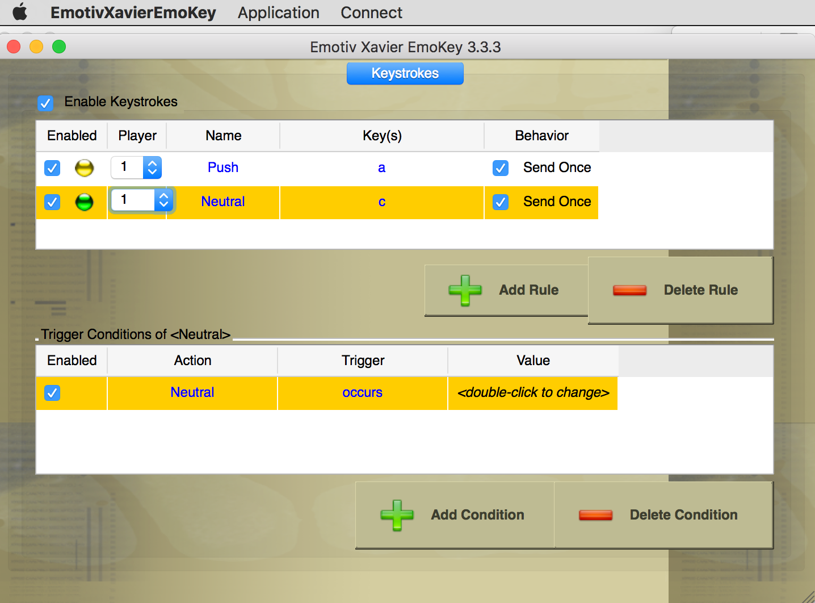

Eventually Reconnect the keys. Enabled should turn green.

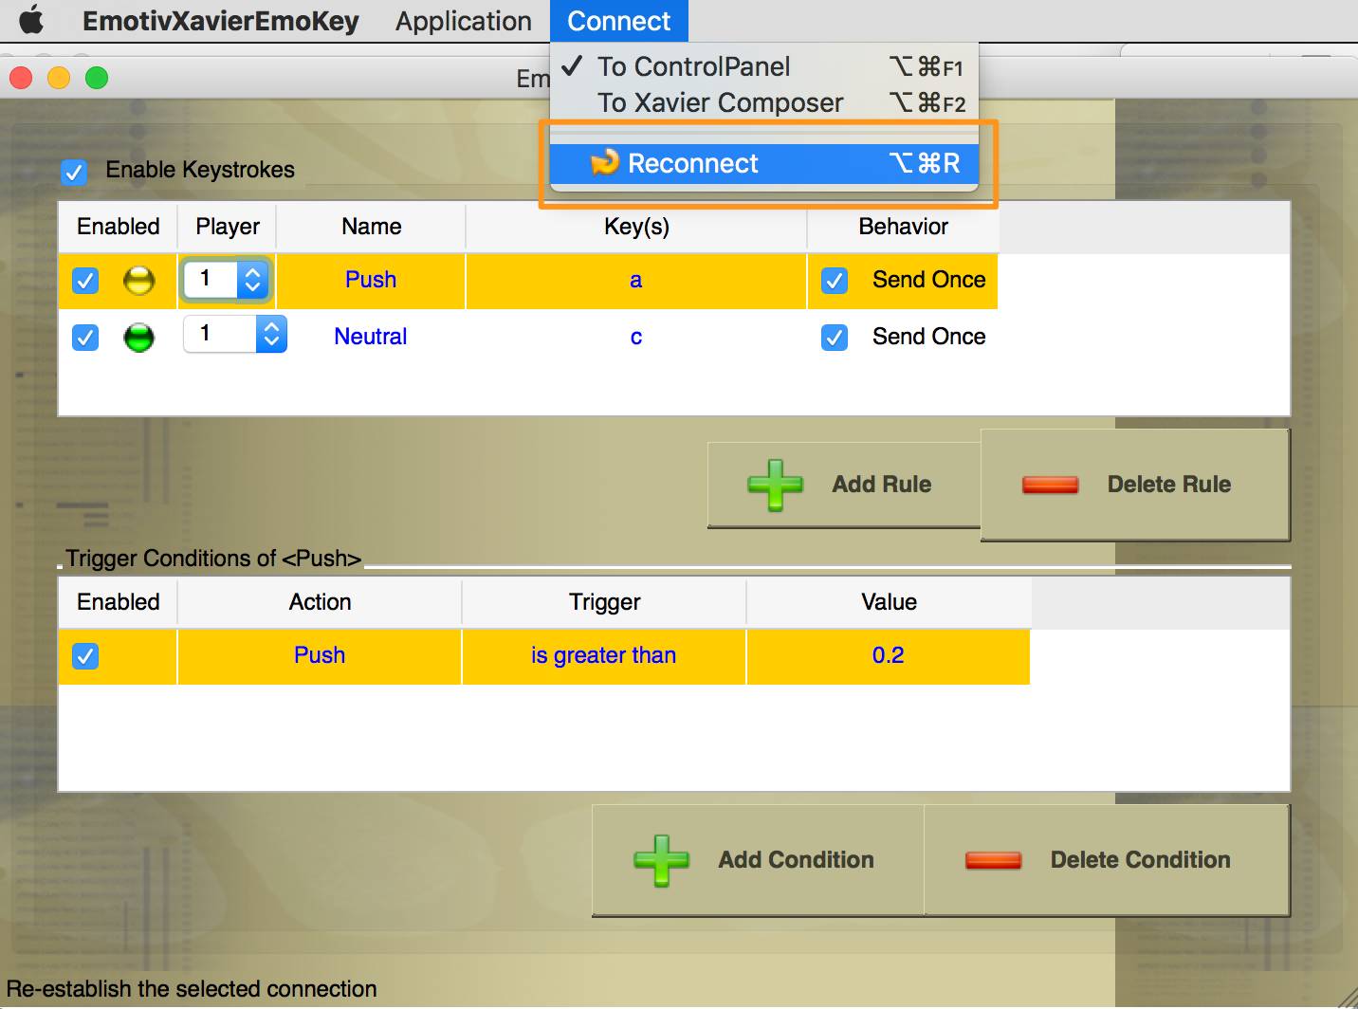

Because Guest user is used, training and other settings are not saved and every time the application restarts, the operations above must be repeated.

## Demo run

- Switch on and wear headset

- Start Emotiv Control Panel

- Start Emotiv Emokey

- In Emotiv Control Panel check that at least 3 sensors are green

- Train Emotiv (see Emotiv Control Panel section)

- Check that ‘BB8 motion control’ flow in NodeRed is deployed

- Start bb8.js

- Open in a browser bb8.html and focus on Input field

Good luck!

Notes:

RGB value is configured in BB8.js

Head front is zero degree

NodeRed on Bluemix – receive message, limit, switch, payload, publish to node.js app

BB8.html (MQTT) - NodeRed – IOT Platform –(MQTT)- BB8.js on local –(Bluetooth) - BB8

Collison detected = stop and light up purple

Code level BB8 commands:

.roll (speed int, direction int)

.color (r int, g int, b int)

.onCollision ({})

Speed is between 0 – 2800

Json publishes push, pull and neutral variables every time, incrementing at speed of 30